**ISSA Show  
COST/BENEFITS WORKSHEET**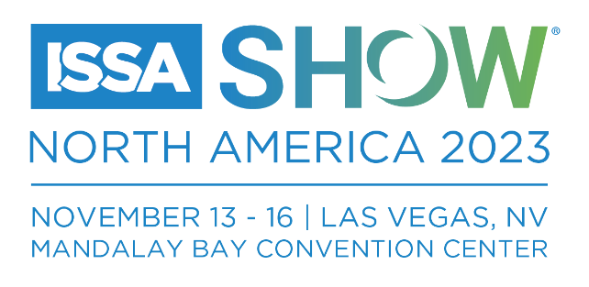

|  |  |
| --- | --- |
|  | **COST** |
| **REGISTRATION FEES**  Varies. Early-bird deadline is September 30, 2023. [Get info here](https://www.issashow.com/en/attend/registration-packages.html). | $ |
| **FLIGHT**  Most major airlines are offering discounts. Get [info here](https://www.issashow.com/en/travel/travel-discounts.html). | $ |
| **HOTEL ACCOMMODATIONS**  We offer discounted hotel rooms in Las Vegas. [Get info here](https://compass.onpeak.com/e/12605070/0#hotels). | $ |
| **TRANSPORTATION: AIRPORT TO/FROM HOTEL**  We have partnered with a car-rental company offering discounts. [Get info here](https://www.issashow.com/en/travel/travel-discounts.html). | $ |
| **MILEAGE REIMBURSEMENT** | $ |
| **PARKING REIMBURSEMENT** | $ |
| **FOOD/PER DIEM**  Suggestions:  • Breakfast = $16  • Lunch = $17-$20  • Dinner = $31-$35  • Snacks/Coffee = $5-$8 | $ |
| **TOTAL ASSOCIATED COSTS** | $ |

|  |  |  |
| --- | --- | --- |
|  | **Key Takeaway Desired** | **Estimated Value and/or Contribution to the Company** |
| Session 1 |  |  |
| Session 2 |  |  |
| Session 3 |  |  |
| Session 4 |  |  |
| Session 5 |  |  |
| Session 6 |  |  |
| Session 7 |  |  |
| Session 8 |  |  |
| Exhibitor 1 |  |  |
| Exhibitor 2 |  |  |
| Exhibitor 3 |  |  |
| Exhibitor 4 |  |  |
| Exhibitor 5 |  |  |
| Exhibitor 6 |  |  |
| Other |  |  |